We found that Cerberus back again as coronavirus at 2020/3/19.

[http://corona-apps.com/Corona-Apps.apk](https://www.virustotal.com/gui/url/074047bf4c7fe335641797267993cc75cf5001106516dcced3ce4e1277372000)

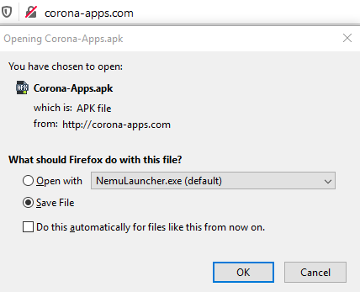



sha256: 93288d18a7b43661a17f96955abb281e61df450ba2e4c7840ce9fd0e17ab8f77

detection name: AndroidOS_Hqwar.HRXI

Cerberus Payload

Sha256: 6A22EEA26C63F98763AA965D1E4C55A70D5ADF0E29678511CF303CB612395DF0

Detection Name: AndroidOS_CerberusPayload.HRX